Helyar, Kevin
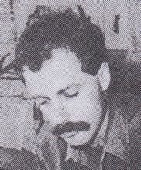
Graduated from Dwellingup Cadet School in late 1970s.
Dieback interpreter in 1980s. Forester at Bunbury Inventory in 1992. Operational Auditor with Management Audit Branch 2001.

